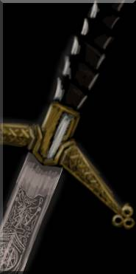  Highlander’s Claymore  A rare design in these parts, with an unusually keen edge.  Great Sword (+1 Damage); Value 300.  Melee; 2-Hand; Parry -1;  Damage Str+d10+1;  Wt 12 lb.  Superior Edge. Increased damage. | 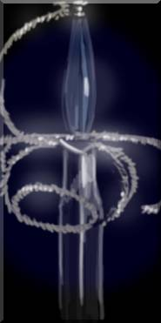  Ebony Rapier  A finely-balanced blade with a wrought wire hand guard, and a grip of polished ebony.  Rapier (+1 Parry); Value 350.  Melee; 1-Hand; +2 Parry; Damage Str+d4; Wt 3 lb.  Superior Guard. Increased Parry (total of +2). | 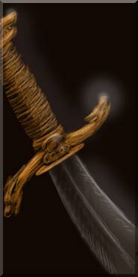  Wolf’s Head Cutlass  The cross-guard and pommel are bronze, wrought to suggest snarling wolves’ heads.  Short Sword (+1 Fighting); Value 100.  Melee; 1-Hand; Damage Str+d6; Wt 4 lb.  Superior Balance. Fighting +1.
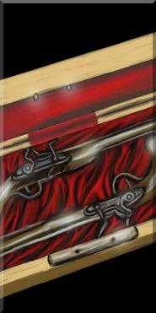  Dueling Pistols  A pair of breach-firing pistols in a watertight case.  2 Turn-Out Pistols (+1 Shooting); Value 600 (set).  Ranged (powder); 1-Hand; Damage 2d6+1; Range 10/20/40; Min Str d6; Reload 2 actions; Wt 5 lb.  Accurate. Shooting +1. | 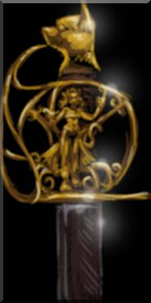  Cat’s Blade  The hand guard depicts a woman in the company of cats – and the pommel is shaped like a cat’s head. Someone likes cats.  Rapier (+1 Fighting); Value 200.  Melee; 1-Hand; Damage Str+d4; Wt 3 lb.  Superior Balance. Fighting +1. | 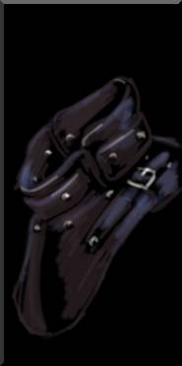  Lucky Leather Gorget  A leather neck protector.  +1 armor only against called attacks to head; Wt 1 lb; Value 50.  Lucky Item. Once, wearer may add 1 to number of wounds negated by a Soak roll. This item is destroyed.
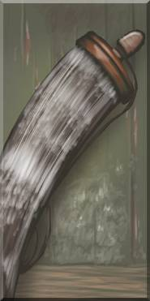  Extra-Fine Powder Horn  A polished bull horn filled with gunpowder, with a pouch of shot and cotton wadding.  Wt 1 lb; Value 50; 10 shots (powder & shot).  Extra-Fine Gunpowder (p. 207, PotSM). Increases the range brackets of regular black powder weapons by 50%. | 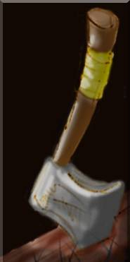  Sturdy Hatchet  A simple, but well-made tool and weapon.  Axe, Throwing; Value 100  Melee/Thrown; 1-Hand; Damage Str+d6; Range 3/6/12; Wt 2 lb.  Well-Weighted. +1 to Throwing rolls to hit. | 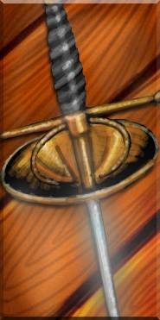  Steel Épée  Sharp only at the tip, with a rigid, triangular-cross-section, fuller groove, and Italian grip.  Épée; Value 400.  Melee, 1-Hand, +1 Parry, AP 1, Damage Str+d4, Wt 2 lb.  Precision. AP 2 and +1d8 dam on one or more Raises.  Thrusting. Cannot Sweep.
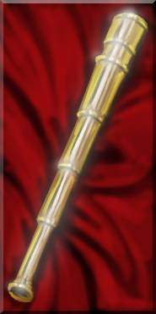  Mariner’s Spyglass  Beautifully engineered, with lenses of great precision and quality.  Wt 1 lb; Value 500; Treasure.  Spyglass. +2 Notice to spot distant objects when looking through the spyglass. | 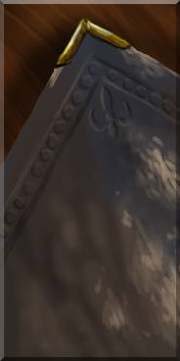  Smuggler’s Journal  A mixture of tedious records and colorful exploits of a long-dead smuggler.  Wt 2 lb; Value 100.  Book. +1 bonus to Knowledge (Area: Spanish Main). | 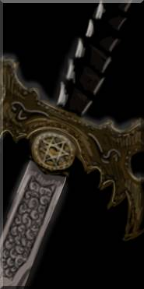  German Zweihänder  A huge and somewhat unwieldy blade, with elaborate parrying hooks on the cross-guard.  Great Sword (+1 Parry); Value 500.  Melee, 2-Hand, -0 Parry, Damage Str+10, Wt 12 lb.  Improved Guard. Parry penalty reduced to -0.
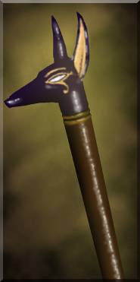  Staff of Anubis  A sturdy cedar staff with an ebony headpiece inlaid with gold, crafted to resemble a jackal’s head.  Staff; Value 500; Treasure.  Melee; 2-Hand; Parry +1; Reach 1; Damage Str+d4, Wt 8 lb.  Blessed. Additional +1 to Fighting and damage vs. Undead. | 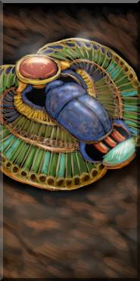  Scarab Amulet  A golden amulet with a scarab of lapis lazuli, inlaid with jade, turquoise, agate and carnelian.  Wt 1 lb; Value 500; Treasure.  Lucky. Grants +1 benny at the start of each session. (Must be used first; cannot be used for Experience Points. Only one lucky item per person.) | 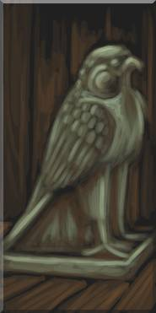  Falcon Statue  A figurine of a perched falcon, carved from dark green stone with a waxy luster.  Wt 7 lb; Value 50; Treasure.
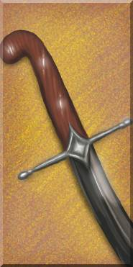  Dark Steel Scimitar  The curved blade is darkly stained and razor-sharp, with a polished cedar grip.  Long Sword (+1 Damage); Value 250.  Melee; 1-Hand; Damage Str+d8+1; Wt 8 lb.  Superior Edge. Increased damage. |   Maltese Cross  A golden crucifix in the style of the Knights of Malta.  Wt 1 lb; Value 500; Treasure.  Blessing of Courage. Wearer gains +1 to Guts checks vs. Fear. | 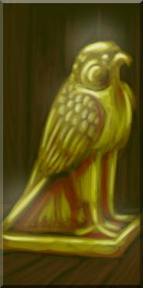  Golden Falcon of Malta  A hollow gold figurine of a perched falcon – its true value once disguised by a layer of waxy dark green enamel.  Wt 7 lb; Value 500; Treasure.  Lost Relic. Bearer will gain 2 Fame if he returns this lost relic to the Knights of Malta.
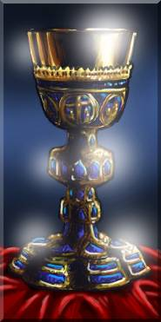  Sacramental Chalice  A golden chalice inlaid with lapis lazuli, intricately ornamented with Biblical scenes.  Wt 1 lb; Value 500; Treasure.  Lost Relic. Bearer will gain 2 Fame if he returns this lost relic to the Knights of Malta. | 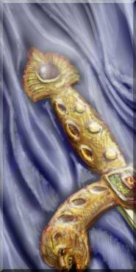  Crusader’s Sword  The cross-guard depicts two roaring lions, and two amber gems are set in the pommel.  Long Sword; Value 400; Treasure  Melee; 1-Hand; Damage Str+d8; Wt 8 lb.  Blessed. Additional +1 to Fighting rolls and damage vs. Undead. | 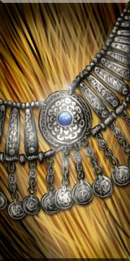  Bedouin Amulet  A necklace of silver beads, chains and coins, with a polished blue lapis lazuli hemisphere set in a silver amulet.  Wt -; Value 100; Treasure.
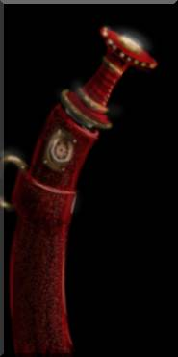  Ethiopian Shortsword  A medallion on the pommel depicts the Queen of Sheba.  Short Sword (+1 Damage); Value 100.  Melee; 1-Hand; Damage Str+d6+1; Wt 4 lb.  Superior Edge. Increased damage. | 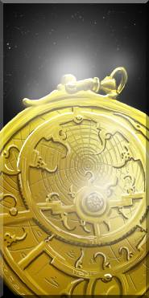  Persian Astrolabe  Exquisitely and precisely wrought, with a detailed star chart on the back.  Wt 1 lb; Value 300; Treasure.  Astrolabe. +2 bonus to Knowledge (Navigation) or Boating roll when navigating. | 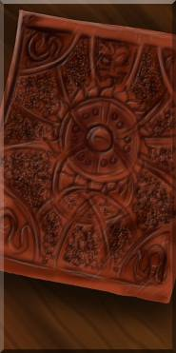  Privateer’s Journal  The cover is embossed with an elaborate knotwork crucifix pattern. Inside are tales of a privateer’s struggle against corsairs on the Mediterranean.  Wt 2 lb; Value 100.  Book. +1 bonus to Knowledge (Area: Barbary Coast).
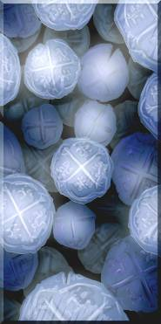  Silver Reales  A cache of Spanish coins in one-real and eight-real (“pieces of eight”) denominations.  Wt 1 lb; Value 50; Treasure. | 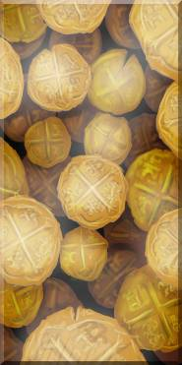  Gold Doubloons  A hoard of stamped gold coins.  Wt 1 lb; Value 200; Treasure. | 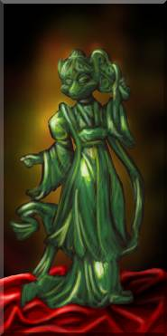  Fox Spirit Figurine  A strange jade figurine of a woman with a fox’s head and two tails.  Wt 1 lb; Value 300; Treasure.
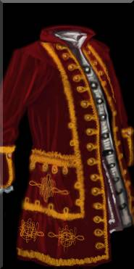  Captain’s Brigandine Coat  A gold-embroidered red coat with small metal plates sewn into the lining for lightweight protection.  Brigandine (“Leather”, half weight); Value 150.  +1 Armor; Covers torso, arms, legs; Wt 3 lb. | 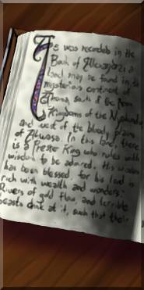  Inquisitor’s Tome  The brass-bound journal of a possibly deranged inquisitor bent on rooting out heretics, witches, and … monsters?  Wt 10 lb; Value 100.  Book. +1 bonus to Knowledge (Occult) | 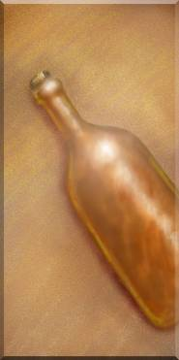  Rum  A bottle of sugar cane rum.  Wt 1 lb; Value 5.  Liquid Courage. If consumed as a full action, grants a +4 to Guts checks, but a -1 to all Agility and Smarts-linked rolls, until imbiber sleeps it off.
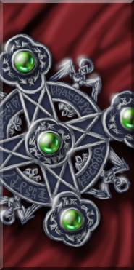  Inquisitor’s Cloak  A blood red cloak with a silver crucifix clasp, inset with polished green tourmaline gems.  Wt 3 lb; Value 50.  Blessed Protection. Wearer has +1 to Parry and +1 to Soak rolls vs. unholy attacks. | 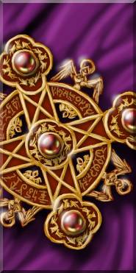  Dark Cloak  A royal violet cloak, with a golden brooch. In the shadows, the cloak looks surprisingly dull and grey.  Wt 3 lb; Value 100; Treasure.  Camouflage. Stealth +1 in Dim light or darker, when worn. | 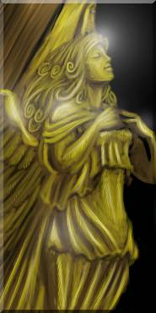  Angel Figurehead  A gilded figurehead, reputed to be blessed by a saint, though the details are vague.  Wt 40 lb; Value 2500; Treasure.  Blessed Figurehead. Grants an extra benny each session to the ship’s crew, to use on one ship-related roll (see p. 208).
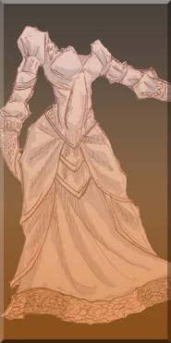  Ballroom Gown  An exquisite silk dress.  Wt 6 lb; -1 Agility; Value 50.  Flattering Dress. If worn by a woman with Charisma 0 or better, grants a +1 bonus to Charisma. | 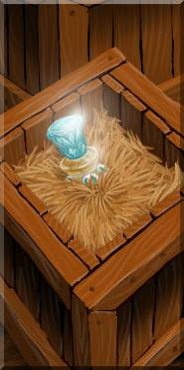  Healing Salve  Four jars of a rare ointment that stops infection and aids recovery from wounds.  Wt 4 lb; Value 1200 (for 4).  Salve. Used every day for 5 days, grants +2 to natural Healing rolls. Each jar has enough for one Healing roll. | 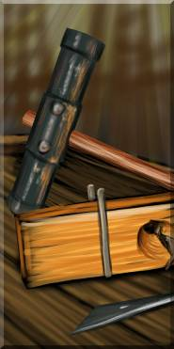  Shipwright’s Tools  Chisels, a mallet, a fore plane, bevel, and assorted other carpentry tools.  Wt 30 lb; Value 700.  Tools. +2 to Repair rolls when repairing a ship.
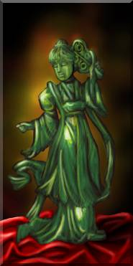  Jade Figurines and Jewelry  Several crates of jewelry and figurines carved from green and white jade.  Cargo 1; Value 1000. | 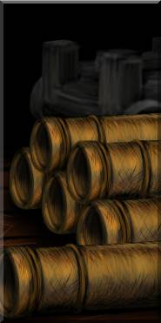  Salvaged Cannons  Cannons and carriages from a shipwreck, though most of the pieces are ruined.  Cargo 1; Value 6000.  Two 8-pdr cannons may be salvaged. Range 8/16/32; Damage 3d6+1; RoF 1; AP 4; Heavy Weapon. |   Fine Silks  Bolts of shimmering silk, in a variety of bold colors.  Cargo 1; Value 800.
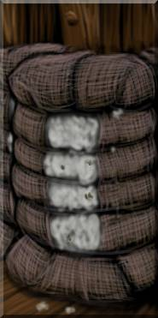  Cotton Bales  Bundles of cotton, wrapped in burlap and twine.  Cargo 1; Value 400. | 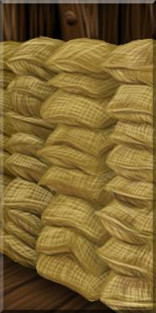  Tea Leaves  Sacks of dried tea leaves.  Cargo 1; Value 500. | 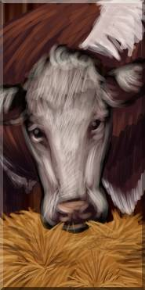  Cattle  2 head of cattle.  Cargo 1; Value 500 (for 2).  Cattle consume provisions (4 units/day each, or 40 total), but come with 30 days’ worth of feed (hay/grass). Each cow slaughtered is worth 250 units of provisions.  (240) Feed Remaining: _____
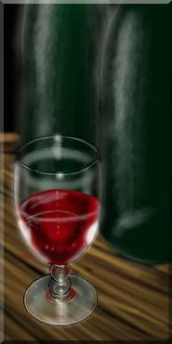  Oak-Aged Wine  Dark bottles of oak-aged wine.  Cargo 1; Value 800 (full).  Expend one unit per crew for equivalent of one night’s Carousing at sea. Only works once per journey, until crew gets some real shore leave.  (80) Remaining: _________ | 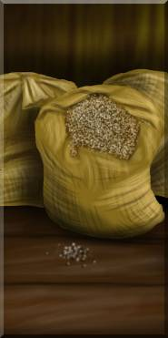  Mediterranean Spices  Herbs, spices and sea salts.  Cargo 1; Value 500 (full).  For every two days you spend a unit of this for each unit of provisions, it only counts as one day toward Cabin Fever effects.  (500) Remaining: _________ |   Cut Lumber  Planks suitable for ship repairs.  Cargo 1; Value 500 (full).  Repairs require 1 unit of lumber per Toughness of the ship, per “Wound” to repair, if you have a Shipwright (p. 42, POTSM).  (100) Remaining: _________
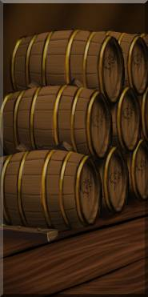  Boar’s Head Ale  Relatively cheap, but potent.  Cargo 1; Value 400 (full).  Expend one unit per crew for equivalent of one night’s Carousing at sea. Only works once per journey, until crew gets some real shore leave.  (80) Remaining: _________ | 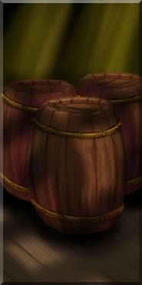  Coastal Provisions  Fruits, dried fish and vegetables, cheese, flour, weak wine and other provisions.  Cargo 1; Value 500 (full).  Provisions (1 unit/crew/day).  (500) Remaining: __________ | 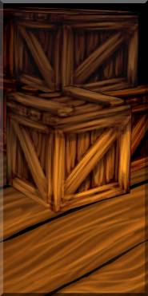  Assorted Housewares  Crates packed with kettles, pots, irons, hoe blades, and other generally useful wares of metal and wood.  Cargo 1; Value 300.

Plunder Cards
The accompanying pages are intended to be printed off on cardstock paper, and cut out to serve as cards to give to your players as “relics” (for Booty) – or, in the case of the cards that list “Cargo,” large amounts of loot that are too heavy for an individual character to carry, and take up an entire cargo hold.

The printed edges are only a rough guide for cutting out. You may find it useful to get a collectible card game binder (or individual pocketed CCG sheets) to organize cards in. (Failing that, a few paper clips are useful.) It’s best to have them cut out ahead of the game, to save time.

Relic cards represent odd relics that pop up occasionally in booty. Rather than rolling on the book’s table, choose the item you think is appropriate – or draw a card randomly. No more than one relic is recommended per “booty”; too many special items and they won’t be special anymore (and too many cards get cumbersome to deal with). In between adventures, once players decide what they’ll trade or sell, they can copy down stats the weapons and other items they choose to keep onto their character sheets. That way, you won’t have to worry about the card vanishing in between sessions.

Value. Values listed are in pieces of eight (or “pesos de oche”).

Weapons. Several of the weapons presented here do not follow the pattern for the superior weapons presented in the book. In many cases, the weapon possesses just one benefit (+1 to damage, Fighting, Shooting, or Parry) rather than the two or more common in the book. These weapons have correspondingly smaller increases to their value compared to the “better” relic weapons found in the book (p. 206, PotSM).

Treasure. Items marked “treasure” are made of precious materials, or are otherwise valuable as trade goods. They may be sold in most cities at the listed value in pieces of eight. (In particular, the “silver reales” and “golden doubloons” are just coinage, worth the listed value.) At the game master’s discretion, a Streetwise roll may be necessary to find a merchant willing to (or able to) pay the face amount for a given treasure. Also, some “treasure” items just might secretly have other properties not advertised. (For instance, perhaps the Falcon Statue is secretly made of gold, but only covered in dark enamel. But if someone were to claw away at it to find out – and discovers that there’s no gold in there after all – then the statue has been damaged for no particularly good reason, and its value would be reduced. Or, perhaps an item may possess a curse only revealed once its new owner hears a warning from a crazy old sailor about it.)

Non-treasure, non-cargo items are subject to the normal rules for Selling Goods (p. 52, PotSM), and normally only sell for one quarter of the listed value.

Cargo is too large and heavy for a single character to carry. It takes up the number of cargo spaces listed (default of 1).

Doubting Thomases may not use item properties with “Lucky,” “Blessed,” or “Blessing” in the name – since such abilities depend upon belief.

Remaining (X). When found, any cargo item has a number of “units” equal to the value in parentheses. Once units are expended, the remaining units may be penciled into the provided space. For example, the lumber represents raw materials usable by a shipwright (p. 42, PotSM). Value of the cargo is reduced by number of units expended (except in the case of cattle, where the “cattle feed” is just an accompanying supply).

Knights of Malta. The second page of this set features several items I created for a “Pirates of the Barbary Coast” campaign. The “Knights of Malta” may be found in (appropriately enough) Malta – one of the few areas of the Mediterranean free of the influence of the Ottoman Empire and the Barbary Coast Corsairs. If a good-hearted hero returns such an item (without expecting recompense) to the order, he gains a bonus to Fame as word spreads of his heroism, piety, and generosity.

The Savage Worlds system and the Pirates RPG are properties of Pinnacle Games (www.peginc.com), and Pirates of the Spanish Main is a trademark of Wizkids Games (www.wizkidsgames.com). This is a fan-made document, and is in no way meant to challenge copyright or trademark status. The artwork in this document is © 2007 by T. Jordan “Greywolf” Peacock. All rights reserved. Permission is granted to print this document for personal use. Special thanks to JackAce, DerFinsterling and Clint Black from the Pinnacle Forums for corrections.

